JNTUA College of Engineering (Autonomous) Ananthapuramu-515002 (A.P) INDIA
TEQIP-III Sponsored Three-Day National Workshop on “Pedagogical Skills for Faculty in Outcome-Based Education “conducted by the Department of Humanities from 6-12-2019 to 8-12-2019
REPORT
The Department of Humanities and Social Sciences, JNTUA College of Engineering, Ananthapuramu, organized a Three-Day National Workshop on “Pedagogical Skills for Faculty in Outcome-Based Education” from 6-12-2019 to 8-12-2019 on the college premises. The workshop focused on pedagogy methods in higher education order which had undergone revolutionary changes during the last two decades. The traditional strategies have become almost obsolete in current scenario where Outcome-Based Education and student centric teaching learning are the need of the hour. About 130 participants from different parts of the country have participated in this program.
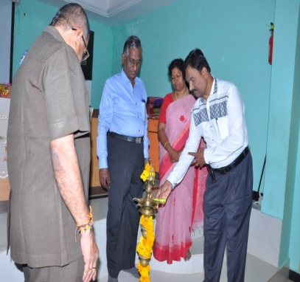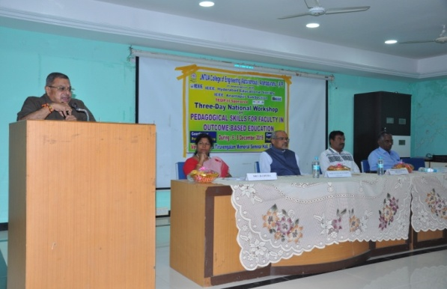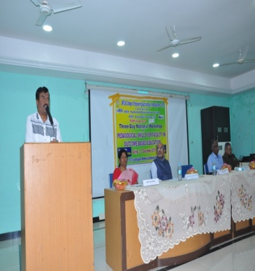
The program started with the registration at 8:30am on 6th Dec followed by the inaugural function. Prof. K.Govindarajulu Principal of JNTUA, Prof V. Sankar, Convenor of the programme, Prof. D.V.S.S. Siva Sarma (Chief Guest) (NIT) Warangal , Prof.S.Lakshmi Narayana, IEEE, Vizag and Dr.V.B.Chithra, Co-ordinator lighted the lamp marking the inauguration of Three-Day workshop.

Prof. K.Govindarajulu, Principal of the college presided over the function. The Coordinator of the program, Dr. V.B.Chithra welcomed the guests and participants. She has briefed about the courses offered by the department of Humanities. Further, she has highlighted the objectives of the workshop with an emphasis on reinforcing the significance of Outcome-Based Education to achieve the goal of education. In his address, Prof. K.Govindarajulu reiterated the significance of the Pedagogical skills and need to change, set goals to bridge the gaps in transforming the knowledge to students. Prof,V.Sankar addressed about the IEEE membership and functions in molding a professional student during the course of education and also to meet the standards of education system.

Key Note Address was presented by the Resource Person and Chief Guest, Prof. D.V.S.S. Siva Sarma Chair, IEEE Education Society, Hyderabad & Prof. in EEE Dept., NIT Warangal. In his speech he briefly introduced the importance of Pedagogical Skills to meet the challenges in Outcome-Based Education themes to be discussed in the Program.

Dr.S.Lakshmi Narayana, Guest of Honour, Ex-Chair, IEEE Vizag Bay Sub-section, briefed the audience about NBA and its relevance to Outcome-Based Education which was discussed elaborately during the sessions.
Professors of the College and other faculty members of all the departments graced the inaugural function.
On the the first day of the workshop, two sessions were handled by Dr.S.Lakshmi Narayana. In his lecture, he focused on the areas of quality through Outcome Based Education in STEM and importance of AICTE for Engineering Colleges. He delivered the traditional education system and transformation to be required to meet the gaps. The continuous evaluation system should be strengthen in teaching learning process. In the afternoon session, Dr.D.V.S.S. Siva Sarma gave lecture on “Paradigms of Teaching Learning process”
On the Second day of the Workshop, Morning session was handled by Prof. Prof. D.V.S.S. Siva Sarma. He focused on “Pedagogical Skills for enabling Digital Age Learners” and “ICT Tools for enabling Digital Learners”. He illustrated exclusively on the setbacks of using technology in teaching. Education is the content of Digital Era. The emerging trends are making the classroom a congenial place and also to set the objectives of the course to meet outcomes. He gave tips to transform digital classrooms to flip classrooms. Teacher has to keep updating to the methods of teaching according to the need of the hour.
The Afternoon Session was handled by Dr. B. Susheela, freelance trainer; Anantapuram delivered the presentation on “Digital Age Teaching - Major Challenges”. She focused on the topic What are the challenges faced by the Digital Age Teachers and solutions to it.

The last day of the workshop, Morning session was handled by Prof. S. Chandra Sekhar Reddy, Prof & Head of Civil Engg, NIT, Warangal. He handled the session on “Orientation Workshop on Outcome-Based Accreditation”. He delivered a detailed content on the fundamentals of OBE and its relevance to NBA. In the afternoon session, he focused on designing both curriculum and delivery mechanisms to build the required skills and competencies. He also explained how to map the course objectives with course outcomes.

The Three Day Workshop came to an end on 8-12-2019 with valedictory function followed by feedback by the participants. They expressed their immense pleasure in conducting a program like this which reinforced their knowledge on OBE.

The Rector of the University, Prof. D.Subba Rao served as the Chief Guest and reiterated the importance of the program and congratulated the organizing team for making this programme a memorable one. Prof. S. Chandra Sekhar Reddy, served as the Guest of honour of the event. He addressed the audience to put the practices effectively to meet the challenges in achieving the OBE.
Prof. M.L.S Deva Kumar served as the Presiding officer and the Convener of the Program Prof. V.Sankar expressed his immense gratitude towards everyone for making the program a grand success. Participation certificates were given to the delegates and finally the program was ended with the national anthem.
